**Dr.D.Y.Patil Institute of Technology**

Pimpri, Pune-411018

A MINI-PROJECT REPORT

ON

**“Face Detection for Exam Surveillance System”**

Submitted by

BCOA30 Aaditya Deshpande

BCOA23 Ayush Agarwal

BCOA33 Rohit Agarwal

BCOA31 Aditya Kulkarni

**Department of Computer Engineering**

2019-2020

**Dr.D.Y.Patil Institute of Technology**

PIMPRI, PUNE-411018

**Department of Computer Engineering**

CERTIFICATE

Certified that the mini-project work entitled **“Face Detection for Exam Surveillance System”** is a bonafide workcarried out by

**Aaditya Deshpande 4CB12ECYYY**

**Ayush Agarwal 4CB12ECYYY**

**Rohit Agarwal 4CB12ECYYY**

**Aditya Kulkarni 4CB12ECYYY**

The report has been approved as it satisfies the academic requirements in respect of mini-project work prescribed for the course.

……………...…………………………

**Subject Incharge**

**Abstract**

Face detection has been a very prominent research field for the past two decades. In most of the works done so far, haar-features have been the key components in the task of object detection and have been very instrumental owing to their simplicity, efficient computation, scalability and ability in the encoding of structural contents of facial images in the form of compact binary representation. In this project, we have developed a new security system for exam surveillance. This system uses a Haar rectangle as its feature, and cascade classifier for face and eye detection.

**Content**

|  |  |  |
| --- | --- | --- |
| **Sr. No** | **Name** | **Page No** |
| **1** | **Introduction** | **5** |
| **2** | **Implementation** | **6** |
| **3** | **Result and Analysis** | **8** |
| **4** | **Conclusions & Future Enhancements** | **9** |
| **5** | **References** | **10** |

**List of Figure**

|  |  |  |
| --- | --- | --- |
| **Sr. No** | **Name** | **Page No** |
| **1** | **Haar-like features** | **6** |
| **2** | **Block Diagram: Exam Surveillance System** | **7** |
| **3** | **Behavior analysis** | **8** |

1. **Introduction**

In recent years, video surveillance has a wide range of applications in the military, economic and other fields, such as the area security monitoring, the tourist statistics of attractions, the banking system of the ATM surveillance. But most work of video surveillance is completed by artificial.  
 In this project, we are improving exam surveillance by monitoring a candidate via a web camera. According to the Josephson Institute’s Center for Youth, an Ethics report revealed that more than half of high school students admitted to cheating on a test, while 74% reported copying their friend's answers. This will lead to the false result of the examination. Hence there is a need for a system that will detect the unfair means and generate an analysis according to the behavior of the candidate. The system is designed to detection typical patterns for actions of concern such as discussions during an exam or looking at other candidates' screen.

When it finds face information it will record it and starts tracking for eyes. The motion of eyes and head movement should be detected in order to make a judgment. The natural movement and blinking of eyes are considered a genuine case and will not hamper on a result of the candidate.

1. **Implementation**

In this project, we have used a Haar cascade classifier for face and eye detection of the candidate. It is a machine learning-based approach where a cascade function is trained from a lot of positive and negative images. It is then used to detect objects in other images. As a video is nothing but a collection of images known as frames. We are applying a cascade classifier on those frames for tracking candidate activities. This needs to be done for each frame hence we need a pre-trained model for face and eye detection of candidates to speed up a process.  
 Converting captured frame into a grayscale image of it for reducing complex calculations and dealing with 2D arrays, containing pixel brightness intensity value. Haar features shown in the below image are used.

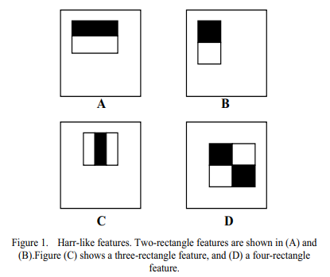

In a cascade of classifiers, features are grouped into different stages of classifiers and applied by using internal parallelism on a captured frame. During the detection phase, a window of the target size is moved over the input image, and for each subsection of the image and Haar features are calculated. This provides us a threshold value that separates non-faces from faces. If a face is captured and only a single eye is detected that means the candidate is looking away from the screen during an exam. This behavior increases the probability of cheating in examination.

Once started to capture each frame they are recorded into a CSV file parallelly. This is done by using a multi-core system. As the process needs to communicate we are using a shared address space. Here one process is for monitoring and another for storing motion data generated by the candidate.

This CSV file contains frames captured so far and the number of times the candidate looked at the screen and out from the screen. This CSV file is finally analyzed at the end of the exam for generating results with candidate behavior. Behaviour is visualized by using graphs.

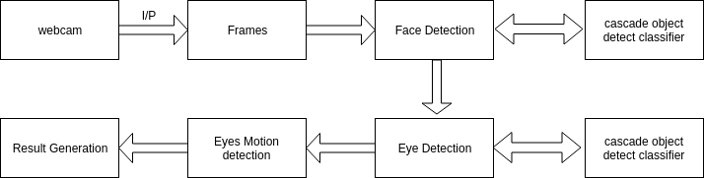

Figure 2: Block Diagram for Exam Surveillance System

From the above block diagram, the working of the system is explained. Analyzing each frame and storing the behavioral data in the CSV file will be done parallelly.

1. **Result and Analysis**

The analysis is done on the gathered data which is stored in the CSV file. For analysis purposes, a simple probability formula is used for judgment purposes. We are assuming the 5% cases are genuine cases, improper light for camera view and miscellaneous errors.  
 After analyzing the data result will also give an idea about the probability of cheating occurred in the current examination.

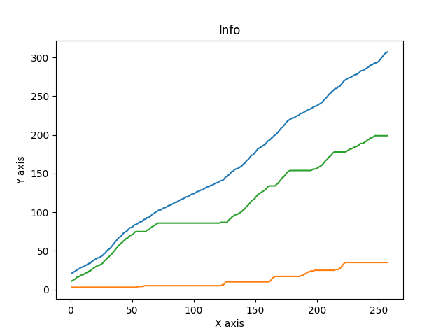

Figure 3: Behavior analysis

Blue colored line shows the fps captured, the green line shows the screen looks in that frame and the orange line gives an idea about the suspicious behavior. This kind of analysis is useful for understanding and making a valid judgment about the candidate's performance.

1. **Conclusions & Future Enhancements**

Video Surveillance, which uses Haar Cascade for face and eye detection can increase the efficiency of supervision in examinations. This will definitely lead to a brighter future for conducting a fair examination.

For future scope, the examiner will be able to set the custom accuracy of this system. The system will send a warning to the candidate that their behavior is suspicious or their face is not getting detected. This technology can be used in Face Detection for Security Surveillance System for criminal investigation.

1. **References**

1)Hoda Qezavati, Babak Majidi, Mohammad Taghi Manzuri (2019). Partially Covered Face Detection in Presence of Headscarf for Surveillance Applications.  
<https://ieeexplore.ieee.org/document/8786004>

2)Seong-Hoon Kim, Jin-Woo Choi (2019). Face Recognition Method Based on Fixed and PTZ Camera Control for Moving Humans.  
<https://ieeexplore.ieee.org/document/8806046>  
  
3)Vikram Mutneja, Satvir Singh (2017). Size-based performance analysis of haar-features for detection of facial images from low-resolution surveillance videos.  
<https://ieeexplore.ieee.org/document/8342739>

4)OpenCV3 Official documentation.   
<https://docs.opencv.org/3.4.1/d7/d8b/tutorial_py_face_detection.html>